**Creating Platform User Interface/Platform Navigator**

**Section 1: Create a Project**

1. Login into the Red Hat OpenShift Console using the credentials provided

2. Expand **Home** menu and click **Projects**.

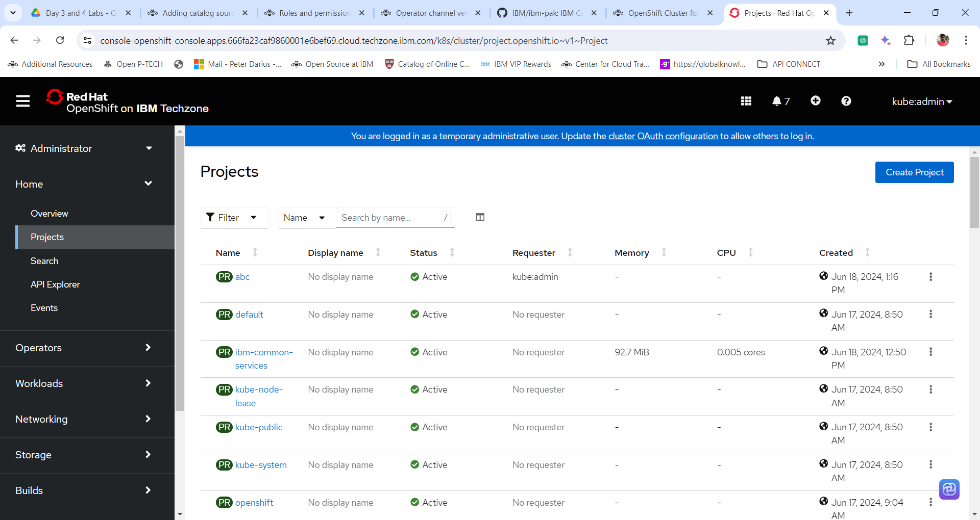

3. Top right corner click on the options **Create Project**.

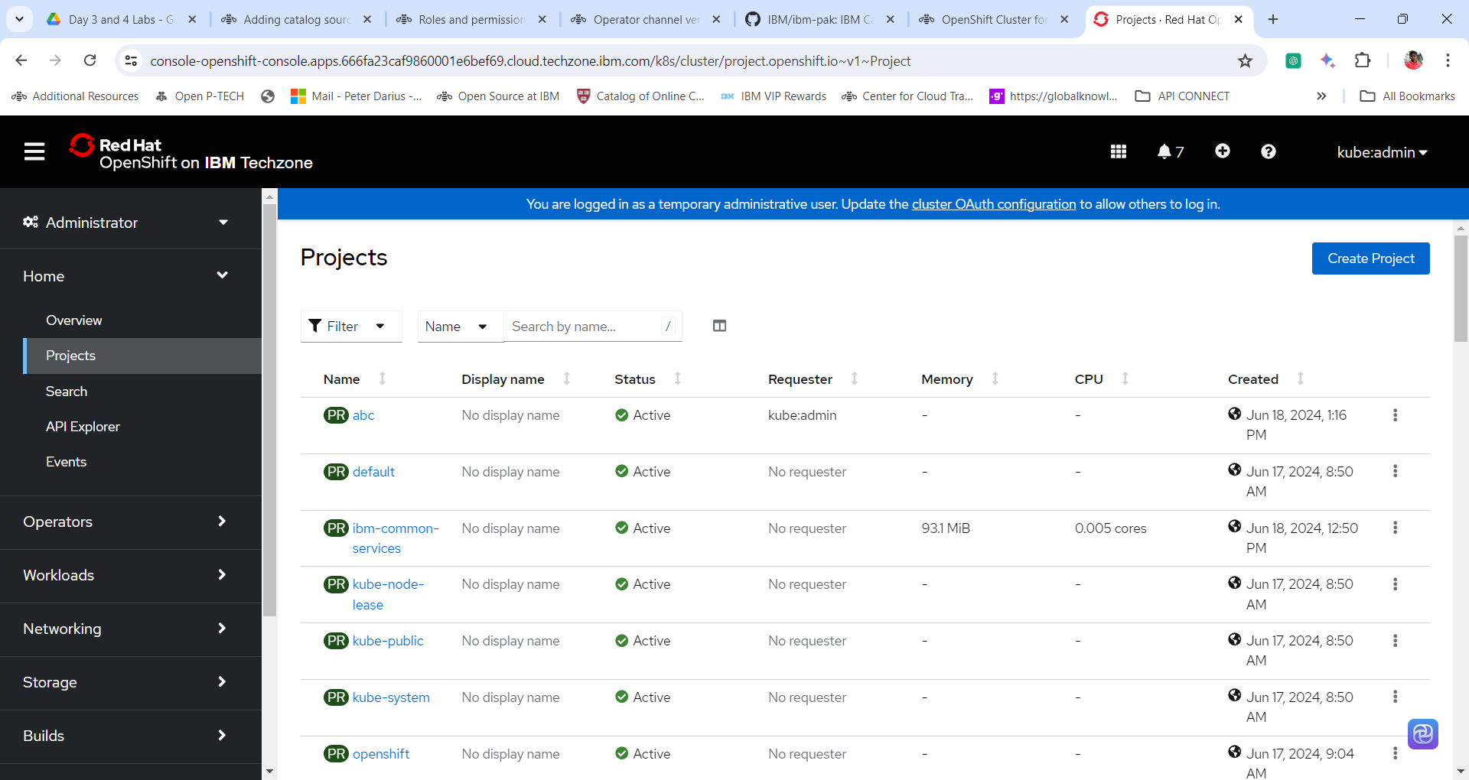

4. Enter the following details in the dialog box.

**Name: cp4i ( Can provide any name)**

**Display Name: cp4i**

**Description: cp4i project**

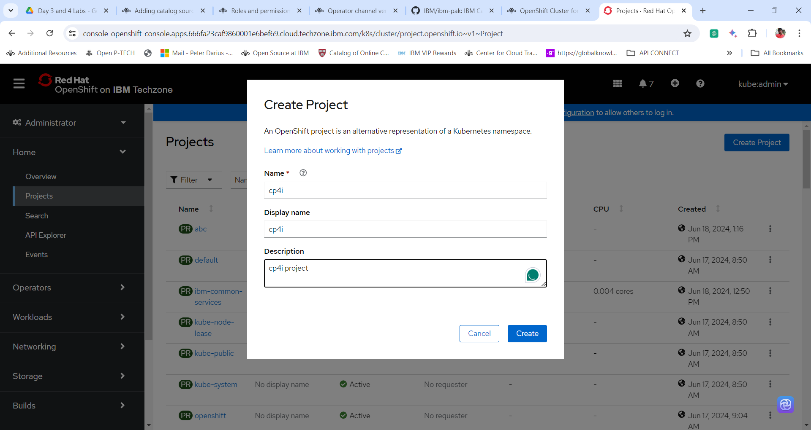

5. Click **Create.**

**Section 2: Create a Platform UI / Platform Navigator Instance**

1. Expand the Operators menu and click on Installed Operators.

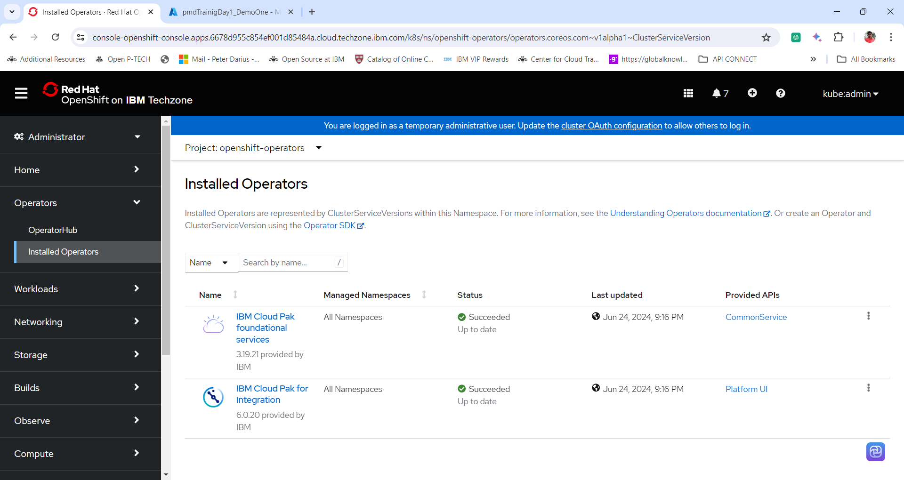

2. Change the project to **cp4i** from Project drop down.

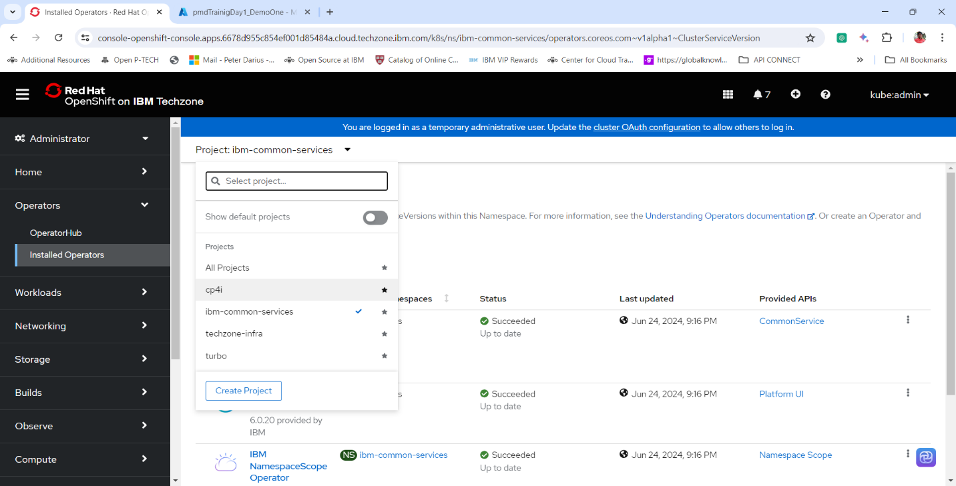

3. In the installed operator window click on the **IBM Cloud Pak for Integration** operator.

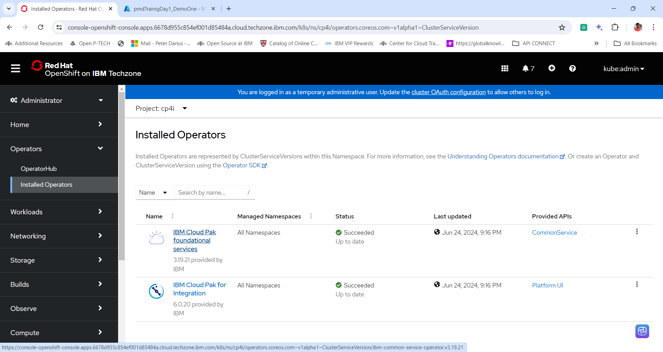

4. Click on the tab **Paltform UI** and click **CreatePlatformNavigator** icon to create an instance of Platform UI or Platform Navigator. ***Important Check if your in cp4i project***.

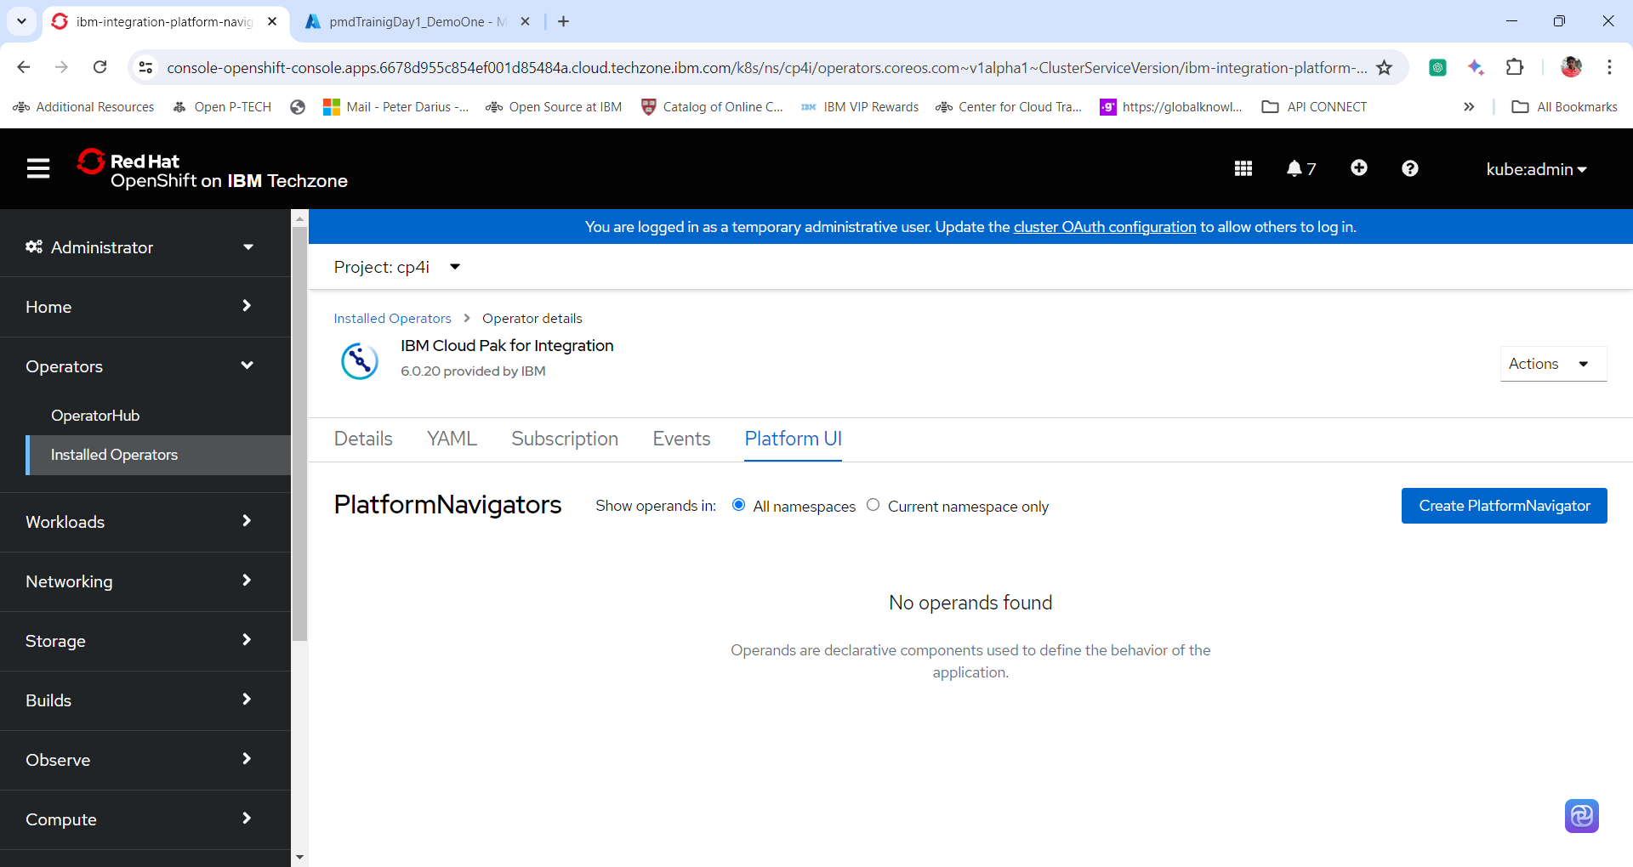

5. In the Platform Navigator config window select the following configuration.

**Name: Keep the default. If you would like to change the default name change it.**

**License: Accept the License**

**Storage:**

**Storage Class: ocs-storagecluster-cephfs**

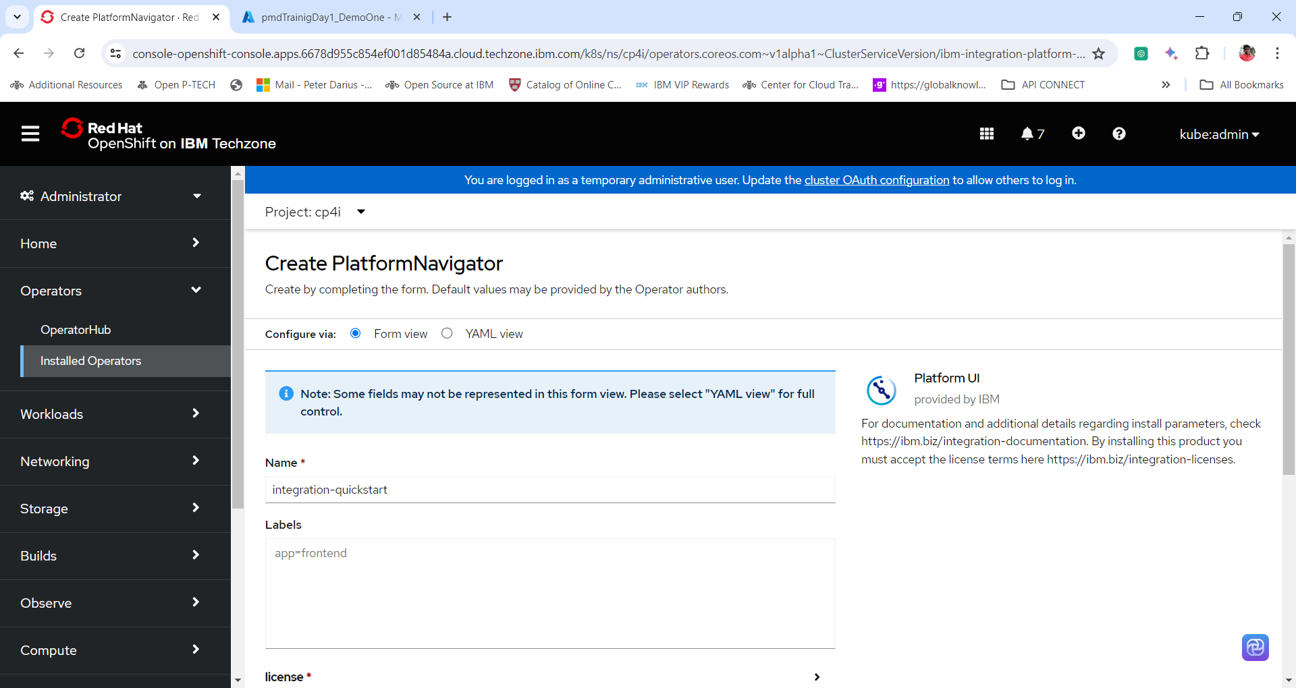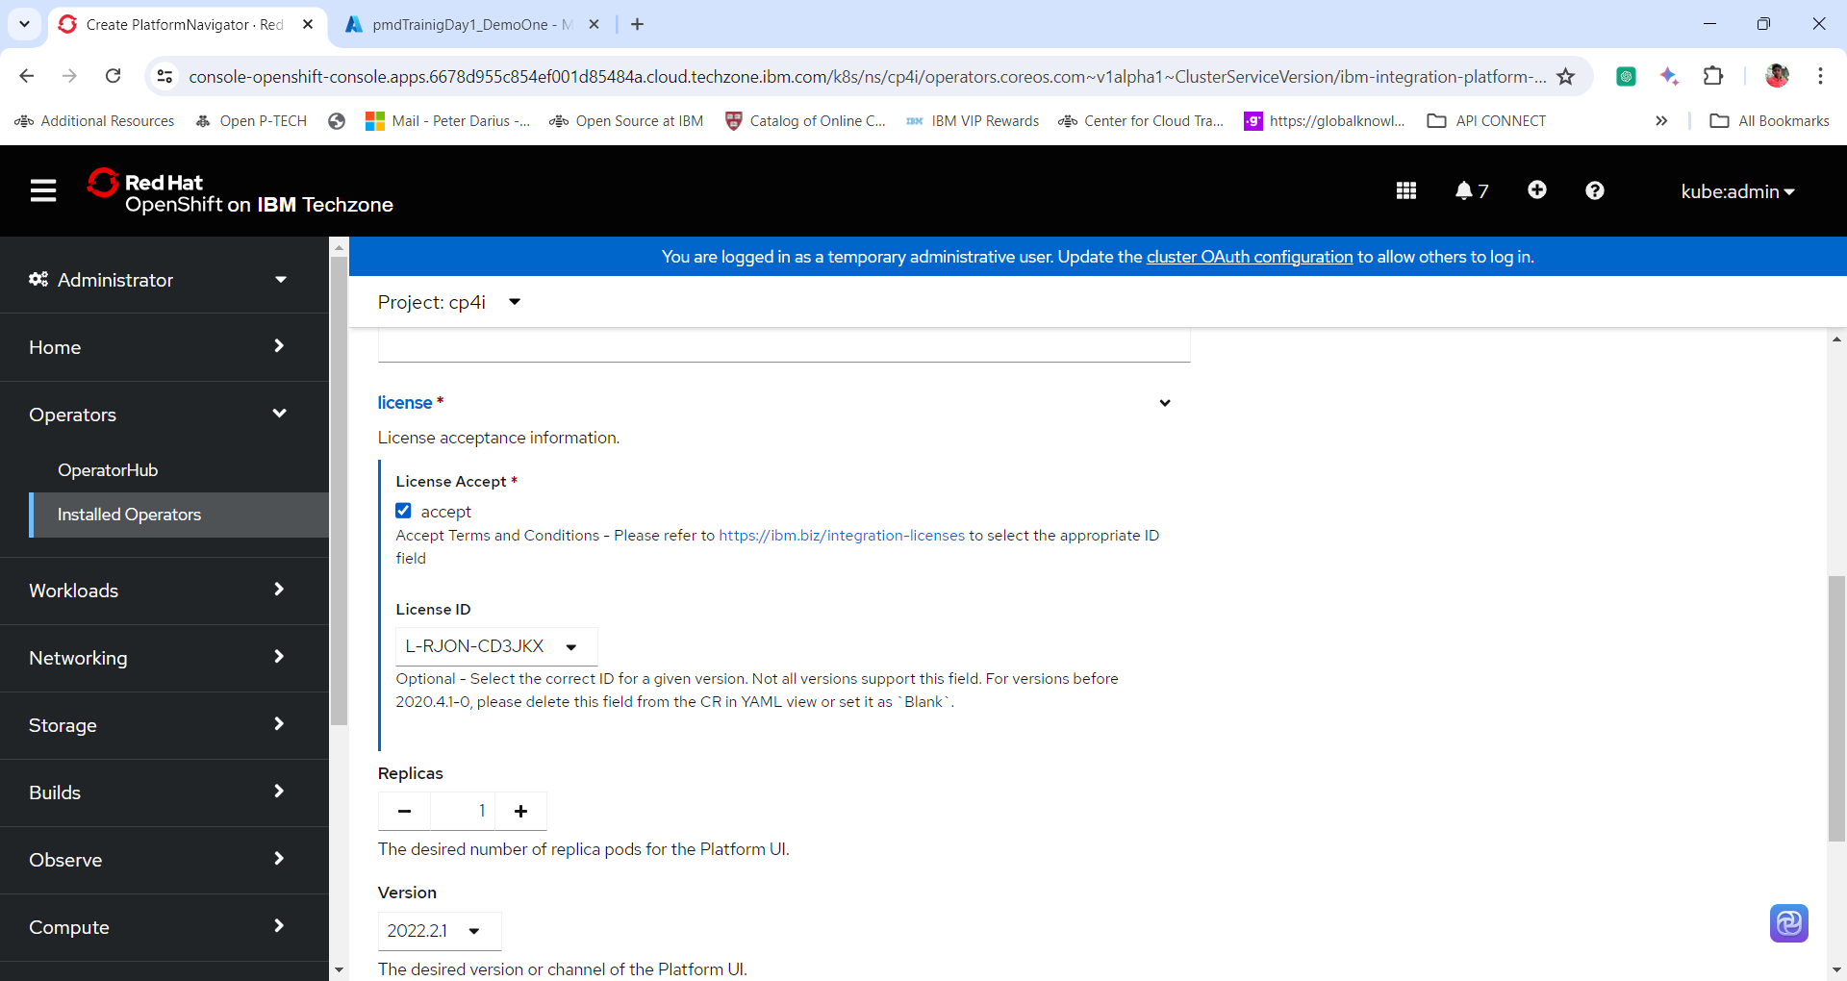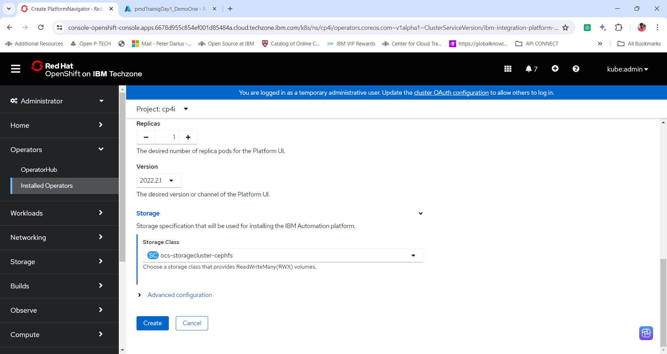

6. Click **Create**.

7. Wait for around 30 to 45 minutes for the Platform Navigator to get installed. To view the progress of the same click on the Platform Navigator name and in Details tab go to the bottom of the screen to view the conditions of the operand or instance installation. And wait for the **status** to be **condition: running** from condition:pending

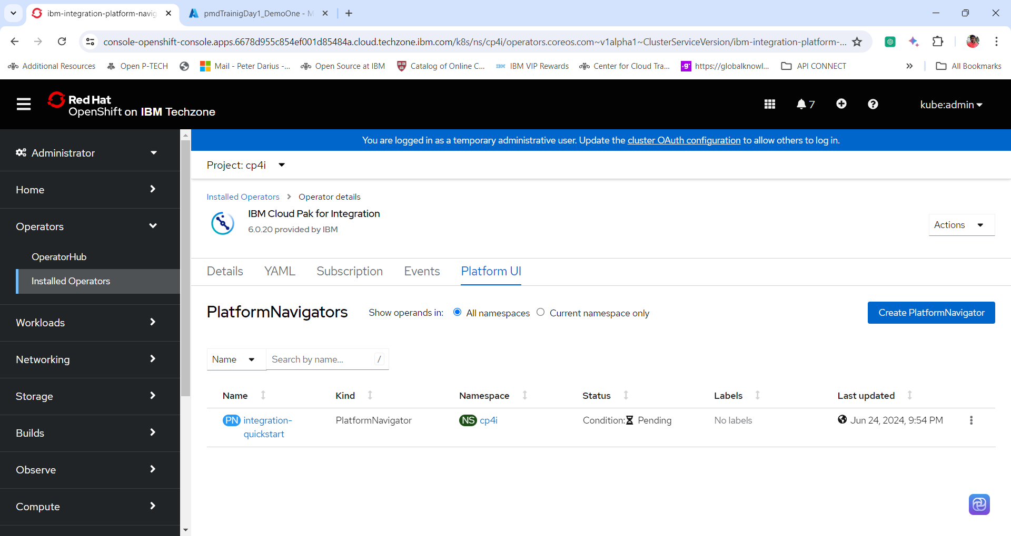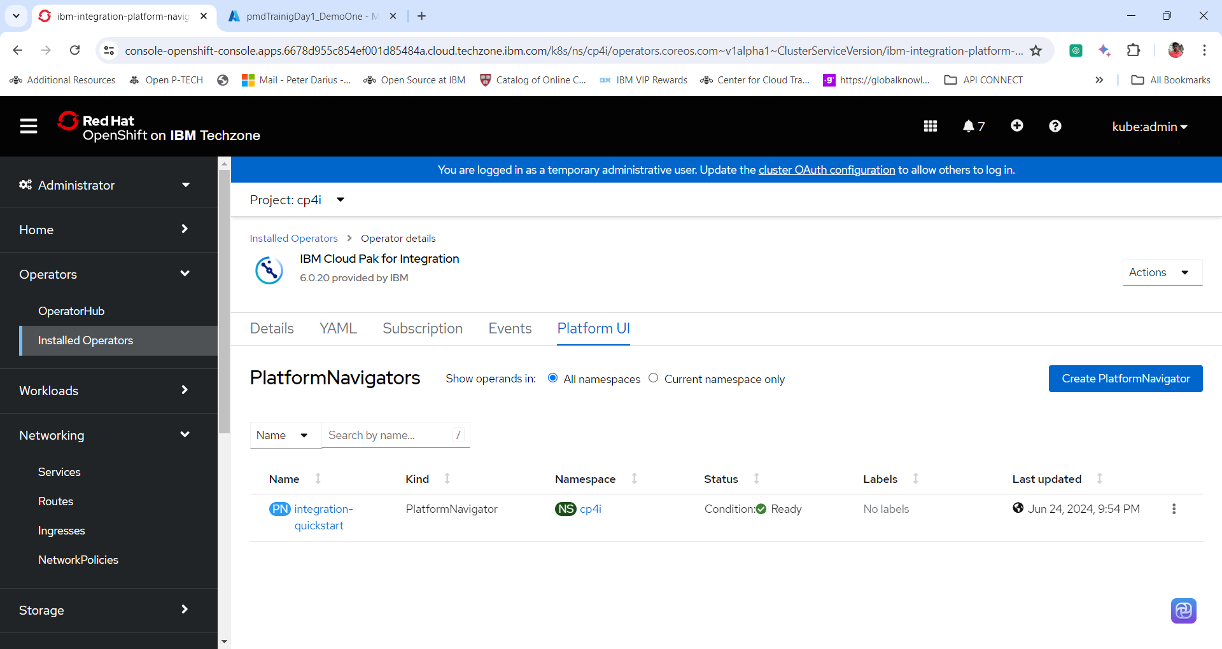

8. Expand **Workloads** and click **pods**, to view the pods created when creating an instance of Platform UI.

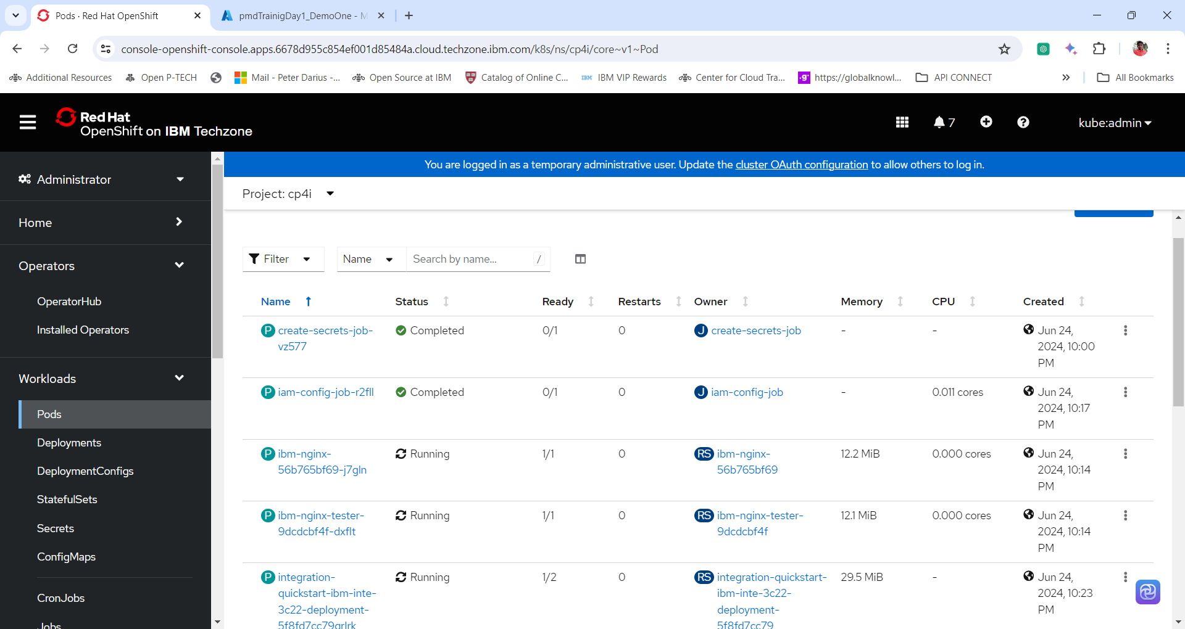

9. Expand **Networking** and click **Routes** to view the routes for the Platform UI named integration-quickstart-pn.

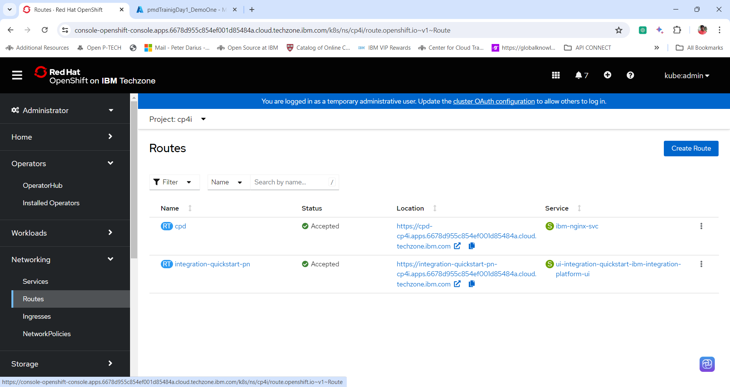

**Section 3: Accessing the Platform UI Dashboard**

1. Expand **Networking** and Click **Route**

2. Change the project to **cp4i**, click on the **URL** under **location tab** for the Name **integration-quickstart-pn** (Name of the platform UI)

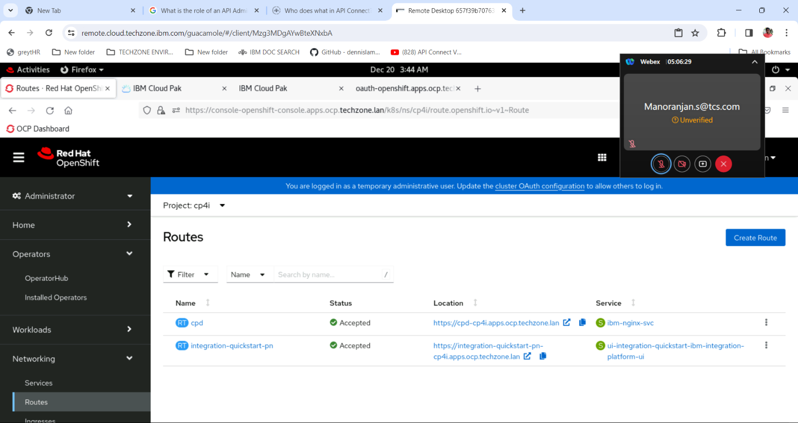

3. Platform UI will open in an another tab

4. To Access the Password/secrets type the following command in the terminal window

oc get secrets -n ibm-common-services platform-auth-idp-credentials -o jsonpath='{.data.admin_password}' | base64 --decode && echo ""

5. Copy the password displayed and log into the Platform UI.

**Username: admin**

**Password:**

**Use Red Hat OpenShift Console to obtain the password/secret**

1. Expand **Workload** and Click **Secrets**. Change the project to **ibm-common-services**.

**Note:** If ibm-common-services is not visible or any other project is not visible enable the option Show default projects.

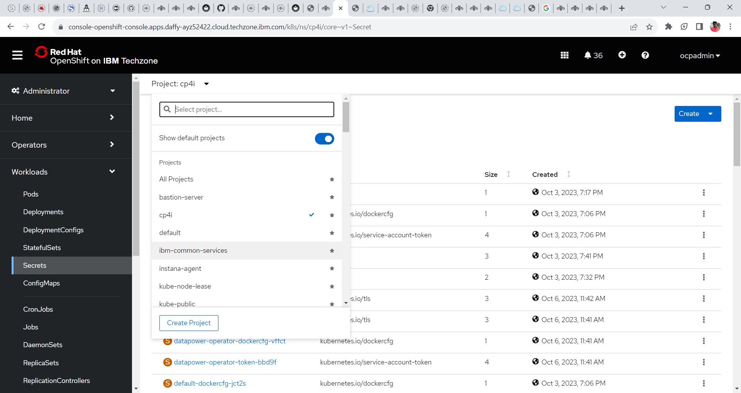

2. In the search box search the following secret **platform-auth-idp-credentials**. And click the same.

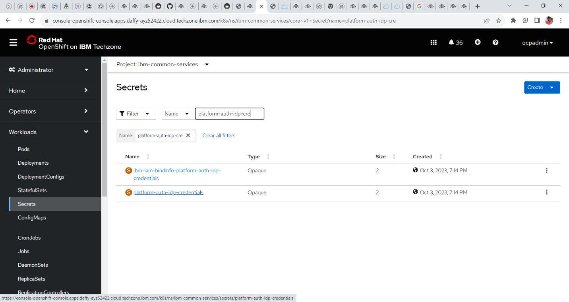

3. Go to the bottom of the page and click **reveal values** in order to reveal the **password**. Copy the password to log into the Platform UI

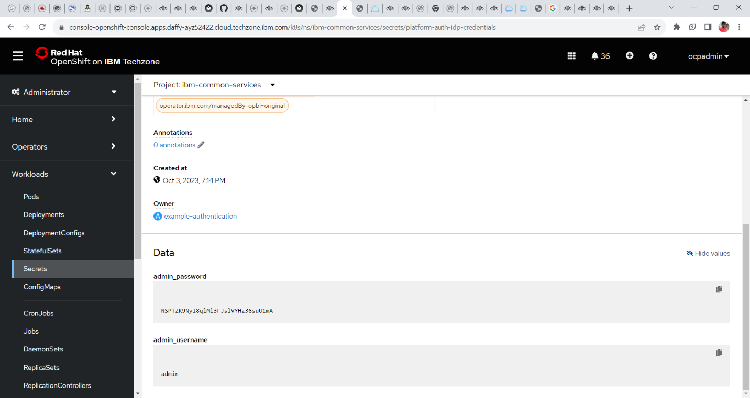

3. Use the password to log in.

4. Welcome page of the Platform Navigator or Platform UI.

